

Customer Shopping Behavior

Analysis

Uncovering insights from transactional data to guide strategic business

decisions.



Project Overview

Goal

Analyze 3,900 purchases to

understand spending patterns,

segments, product preferences,

and subscription behavior.

Data Source

Transactional data from various

product categories.

Outcome

Guide strategic business

decisions with actionable

insights.



Dataset Summary

Key Features

Customer demographics (Age, Gender, Location,

Subscription)

Purchase details (Item, Category, Amount, Season, Size,

Color)

Shopping behavior (Discount, Promo Code, Previous

Purchases, Frequency, Review Rating, Shipping)

Data Overview

Rows: 3,900

Columns: 18

Missing Data: 37 values in Review Rating



Exploratory Data Analysis (Python)

01

Data Loading & Exploration

Imported dataset with pandas, checked structure and summary

statistics.

02

Missing Data Handling

Imputed missing Review Rating values using median per product

category.

03

Feature Engineering

Created age group and purchase frequency days columns.

04

Database Integration

Loaded cleaned Data frame into PostgreSQL for SQL analysis.



Data Analysis (S L) - Key

Findings

1

Revenue by Gender

Male customers generated $157,890, Female customers $75,191.

2

High-Spending Discount Users

Identified 839 customers who used discounts but spent above average.

3

Top 5 Products by Rating

Gloves (3.86), Sandals (3.84), Boots (3.82), Hat (3.80), Skirt (3.78).

4

Shipping Type Comparison

Express shipping users had higher average purchase amounts ($60.48 vs

$58.46).



S L Insights: Customer Behavior

Discount-Dependent

Products

Hat (50%), Sneakers (49.66%), Coat

(49.07%)

had highest discount rates.

Customer Segmentation

3

,116 Loyal, 701 Returning, and 83

New customers identified.

Repeat Buyers &

Subscriptions

958

repeat buyers (more than 5

purchases) are subscribers vs. 2,518

non-subscribers.

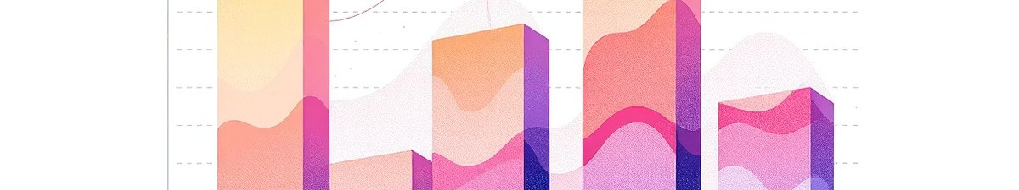

S L Insights: Product & Revenue

Top 3 Products per Category

**Accessories:**

Jewelry, Sunglasses, Belt

**Clothing:**

Blouse, Pants, Shirt

**Footwear:**

Sandals, Shoes, Sneakers

**Outerwear:**

Jacket, Coat

Revenue by Age Group

**Young Adult:**

$62,143

**Middle-aged:**

$59,197

**Adult:**

$55,978

**Senior:**

$55,763



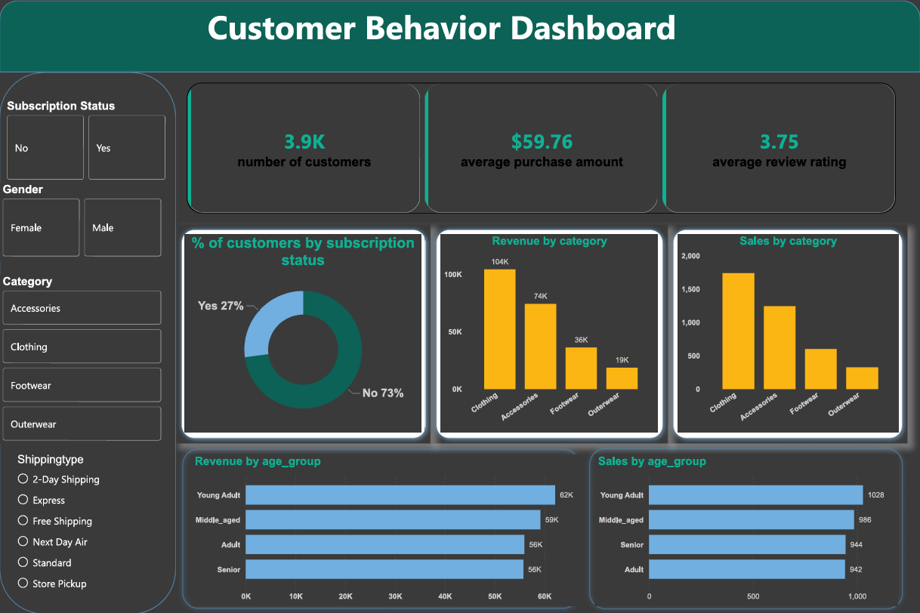



Power BI Dashboard

Interactive dashboard for visual insights.

3.9

K

Customers

59.76

Avg. Purchase

3.75

Avg. Rating



Dashboard Visualizations

% Customers by Subscription

27

% Yes, 73% No.

Revenue by Category

Clothing, Accessories, Footwear, Outerwear.

Sales by Category

Detailed sales figures for each product category.

Revenue by Age Group

Young Adult, Middle-aged, Adult, Senior.



Business Recommendations

Boost Subscriptions

Promote exclusive benefits to increase subscriber base.

Customer Loyalty

Implement programs to reward repeat buyers and foster loyalty.

Review Discount Policy

Optimize discounts to balance sales and profit margins.

Targeted Marketing

Focus campaigns on high-revenue age groups and express-

shipping users.

